Bryant Garcia

Software Development with Java

SDEV 200

05/10/2025

Screenshots

Home Window

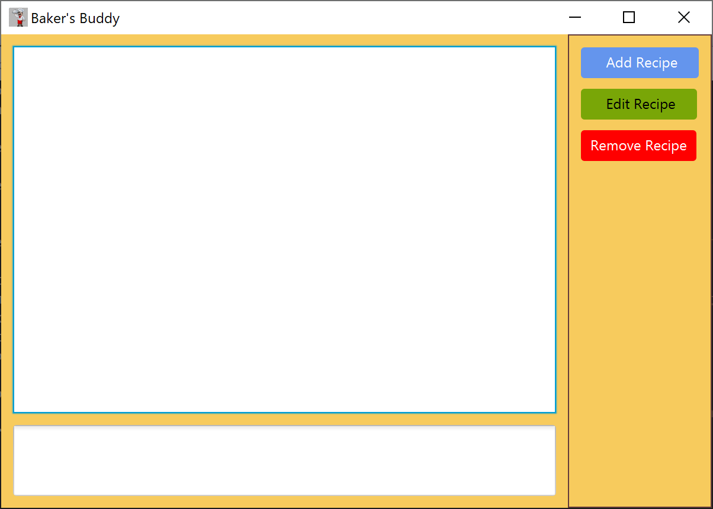

Add Recipe Window

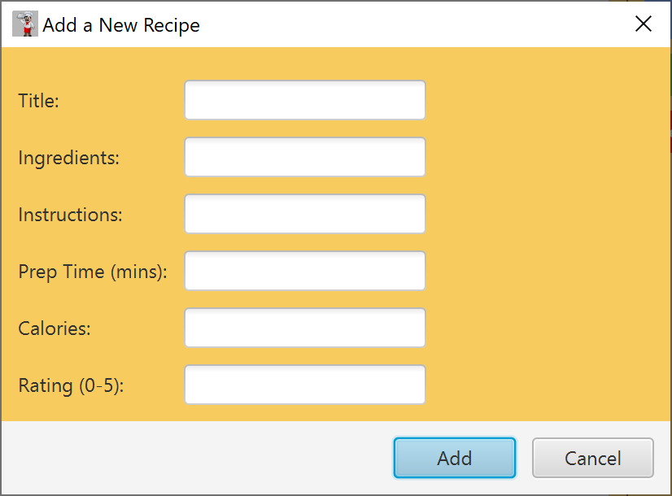

Home Window with Recipes

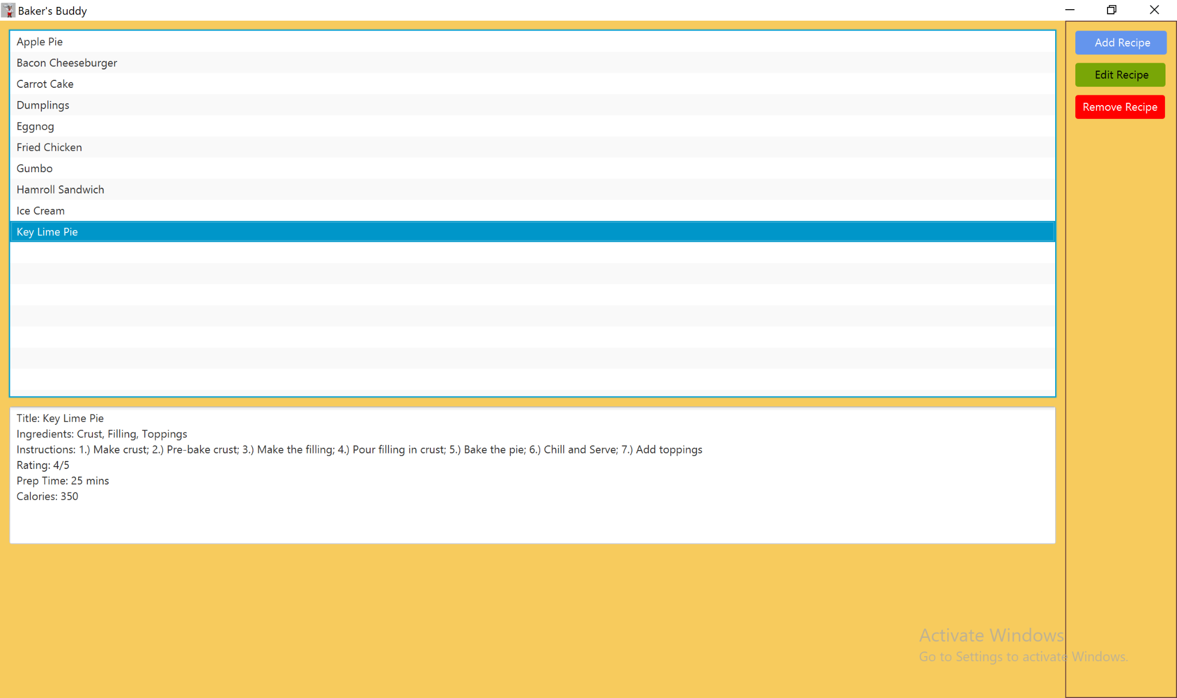

Edit Recipe Window

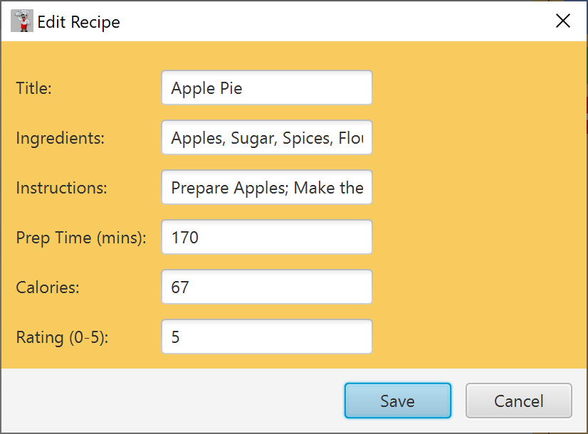

UML Diagram

